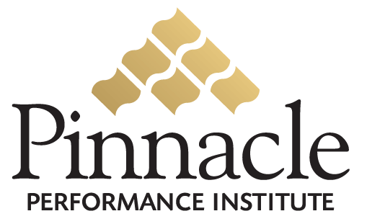

Business

Performance

Solution

Close the Gap between Vision & Execution
Expose Reality… and Act Upon It

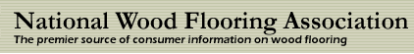

National Wood Flooring Association
111 Chesterfield Industrial Boulevard
Chesterfield, Missouri 63005

Attn: Joe Brown
(800) 422-4556

Table of Contents

Executive Summary 2
Execution Strategy 3
Overview 4
Opportunity 4
Solution 4
Return On Investment 6
Implementation Plan 7
Pinnacle Performance Institute 8
Agreement 9

Executive Summary
The National Wood Flooring Association (NWFA), a non-profit trade association since 1986, represents all segments of the hardwood flooring industry, from manufacturers, to distributors, to retailers, to installers. They provide training and resources for wood flooring professionals to assure that the customer will get high-quality flooring that will last a lifetime.
NWFA desires to expand its membership, increase its non-membership revenue, and to assist its members in meeting their growth and profitability objectives. NWFA is constantly looking for ways to add value for its members and to improve the quality of products and services provided within its industry.
Pinnacle will develop a custom NWFA branded Business Performance Solution to enable NWFA to assist its business members in improving their service fulfillment; increase their customer referrals, employee retention, employee productivity and sales conversion rates. NWFA members will have unlimited access to the Pinnacle Buffet of Fortune 500 quality development and management courses.
Additionally, industry manufacturers, distributors, vendors and expert technicians will be able to provide their comprehensive training to the NWFA members through the NWFA Business Performance Solution.
NWFA members may join the NWFA Business Performance Solution with unlimited access to all assessments, Pinnacle course buffet and communication programs for a small monthly flat-fee of only $49.95. 3-person memberships are only $119.95. NWFA members may optionally join for free certification testing only.
NWFA has no setup or support fees and will generate 25% residual revenue through the promotion of their custom Business Performance Solution memberships. NWFA will earn $45,000 for each 10% of their joining members. NWFA Members will receive a minimum 3000% ROI of $18,000 on a $600 investment.
A dedicated Account Executive assigned by Pinnacle will partner with the NWFA program manager with custom solution implementation and ongoing solution support. The Pinnacle customer support department will also provide additional assistance for the program manager, trainers and members.

Execution Strategy

Pinnacle is dedicated to the successful integration of the Pinnacle Performance Solution within the National Wood Flooring Association (NWFA). The performance benefits can contribute significantly to NWFA’s growth and profitability objectives. For NWFA to fully realize the wide-ranging benefits of its Pinnacle Performance Solution, the following principles must be embraced.

Performance Solution
Your solution can significantly improve the overall performance of the entire organization including the company management, employees and all association members. You and they can effectively measure the strengths and weaknesses of all members. The results of your metrics will drive the effective application of the necessary development to build confidence and competence. The continual process of measuring and building is enabled with effective communication throughout the entire organization. When used as a platform for implementing change your Performance Solution will deliver maximum value, well beyond that of a video training library.

Performance Culture
Your performance solution is integral to the successful improvement of the entire organization. Performance must become integrated within the culture and mindset of every member, employee, manager and executive. In order to Close the Gap between Vision and Execution, NWFA must expose reality… and act upon it. This requires a comprehensive implementation plan rather than just another peripheral program.

Performance Commitment
Regardless of how great your performance solution is, your ultimate success will be completely dependant on the level of commitment from everyone involved including the top management down to the front-line employees and members representing the executed vision of the association. Each user of the performance solution must have a personal commitment and buy-in, through accountability, incentive programs and/or monetary commitments. Complete user commitment will overcome the challenges leading to integration failure contributed to a lowered priority and lowered perceived value.

Overview
The National Wood Flooring Association (NWFA), a non-profit trade association since 1986, represents all segments of the hardwood flooring industry, from manufacturers, to distributors, to retailers, to installers. They provide training and resources for wood flooring professionals to assure that the customer will get high-quality flooring that will last a lifetime. NWFA has more than 3,000 members throughout the world, spanning all ages and all skill levels. Members represent a diversified group of men and women who are working together to exchange ideas, advance their skills, and increase their knowledge.

Opportunity
NWFA desires to expand its membership, increase its non-membership revenue, and to assist its membership in meeting their growth and profitability objectives. NWFA is constantly looking for ways to add value for its members and to improve the quality of products and services provided within its industry.

Solution
Pinnacle will develop a custom NWFA branded Business Performance Solution to enable NWFA to assist its business members in improving their service fulfillment; increase their customer referrals, employee retention, employee productivity and sales conversion rates. NWFA members will have unlimited access to the Pinnacle Buffet of Fortune 500 quality development and management courses.
The NWFA Business Performance Solution will provide all aspects of business development to its members in addition to industry specific knowledge and expertise. Industry manufacturers, distributors, vendors and expert technicians will be able to provide their comprehensive training to the NWFA members through the NWFA Business Performance Solution.
NWFA Members will be able to significantly improve their performance by constantly measuring their strengths and weaknesses, and applying the necessary development to build confidence and competence. The continual process of measuring and building is enabled with effective communication throughout the entire association.
NWFA members may optionally join the NWFA Business Performance Solution with unlimited access to all its assessments, development courses and communication programs for a small monthly flat-fee of only $49.95. 3-person memberships are only $119.95. NWFA has no setup or support fees and will generate 25% residual revenue through the promotion of their custom Business Performance Solution memberships. Members can optionally join for free to take certification tests only. Business memberships can view the results of all their certification tests.

Some of the features of the NWFA Business Performance Solution include:
General Performance Solution Features
- Accessible anywhere with Internet access
- Accessible anytime 24 hours a day, 7 days a week, 365 days a year.
- Secured Access with personal logon name and password for each user
- Secured back-office for program managers, group managers, trainers and members
- Streaming video training supports dial-up and broadband users
- Single flat fee includes unlimited access to everything
Performance Solution Administration and Management
- Custom graphics, pages, colors and training buddy image & biography
- Custom Groups for specific performance goals (departments, roles, projects)
- Public, Private and Semi-private Groups
- Group inclusion of specific members and required or recommended courses
- Selection of public or proprietary assessments and training courses
- Dynamic Surveys to collect performance feedback from team members and customers
- Online conference rooms and discussion boards for each Group
- Electronic suggestion boxes for each Group
- Define expectations for each Group
- Email Manager to send scheduled messages to select members
- Management reporting on member status, usage, and training accomplishments
- Management reporting on member certification and goal accomplishments.
- Managing Buddy to guide the Manager through the necessary administration.

Member Performance Solution
- Member Profile to maintain contact information and secured logon and password
- Training Buddy to assist with all aspects of the solution
- Personal status tracking of all assessments, classes, communications, etc.
- Accountability goals to establish a culture of execution
- Assessments to measure personal and professional needs
- Diagnostic Assessments to address specific problems/needs
- Training Prescriptions for specific individual needs
- 1000+ public training courses on all aspects of life
- Selected company-specific training courses
- Course ratings and feedback from other members
- Multimedia lessons with downloadable attachments
- Take class notes organized by topic and printable
- Lesson quizzes with multimedia questions
- Company branded professional certificates
- Personal expectations for each accessible group
- Group online conference rooms and discussion boards
- Electronic suggestion boxes with reviewable responses
- Company surveys with anonymous feedback

Trainer Performance Content
- Trainer Profile to maintain contact information, picture and biography
- Unlimited number of company trainers
- Maintain secured logon name and password
- Create courses with unlimited number of lessons
- Lesson content of text & pictures, video, audio, Flash, PowerPoint, website links, etc.
- Downloadable lesson attachments for workbooks and reference sheets
- Lesson Quizzes with unlimited multimedia questions
- Quiz questions are multiple choice, fill-in-the-blank, or true/false
- Create assessments to determine proficiency scores
- Create diagnostic assessments to solve specific problems/needs
- Define training prescriptions for specific needs.
- Unlimited multimedia assessment questions
- Assessment questions are multiple choice, fill-in-the-blank, or true/false

Return On Investment

The NWFA will have an estimated investment of $12,000 annually for management and promotion of the solution, Projected revenue for 300 (10%) memberships at $50 per month will yield an annual profit of $45,000(25%) or 375% Return on Investment.

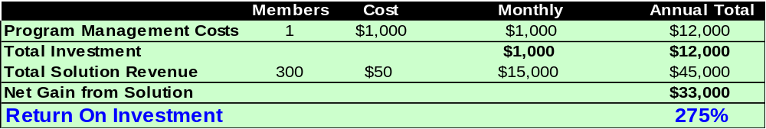

The NWFA member (one-person shop) will have an estimated investment of $600 annually for access to the solution (less than the profit from one job per year). Projected improvements of 5% in customer referrals, 5% in employee productivity, and 5% in sales close rates will yield an estimated $18,000 value or 3000% Return on Investment. Larger businesses will realize even larger performance gains.

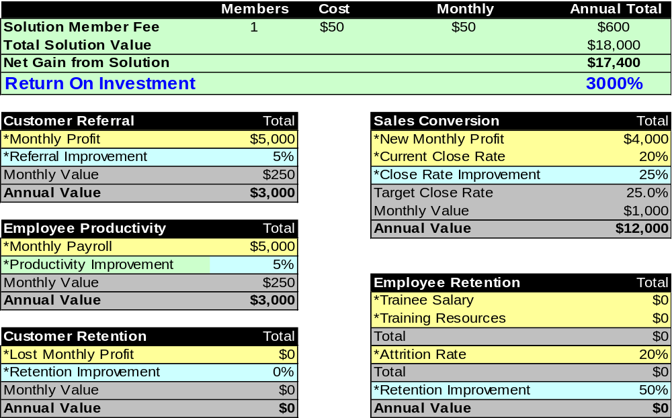

Implementation Plan

The NWFA will start the implementation on May 2, 2005 and will complete the Planning Phase in 7 days on May 9, 2005. The Setup Phase will be completed in 14 days on May 23, 2005, ready for members to start using the solution. The Program Manager will thereafter continually enhance the solution content.

May 2, 2005 (7 days)
Planning Phase Summary
- Identify / Interview Program Manager
- Set Expectations w/ Program Manager and Executive Champion
- Identify Key Players (group managers, influencers, trainers)
- Train Program Manager (phase 1)
- Involve Key Players (advisory group)
- Define Initial Groups and Rollout Priority (departments, roles, projects)
- Define Measurement Needs (existing? create?)
- Define Training Needs
- Define Training Options (existing? create?)
- Define User Expectations (per group)
- Define Promotion Plan (team buy-in)

May 9, 2005 (14 days)
Setup Phase Summary
- Train Program Manager (phase 2)
- Train Group Managers
- Train Trainers
- Setup Folders
- Create Courses
- Create Assessments
- Create Members
- Include Courses
- Include Members
- Start Promotion
- Provide Member Logon Access
- Train Members

May 23, 2005

Usage Phase Summary

MEASURE
- Assessments and Surveys
- Company Gap Assessment
- Knowledge Capital Audit
- Personal Assessments
- Monitor Member Usage
- Review Monthly Reports
- Performance Improvements

BUILD
- Training Buddy of the Month
- Review Measurement Needs
- Review Training Needs

COMMUNICATE
- Monitor Suggestions
- Monitor Conference Rooms
- Monitor Discussion Boards
- Manage Surveys
- Promotion

Pinnacle Performance Institute
The Pinnacle Performance Institute shows companies how to clone their top performers to significantly increase their profits. It does this with a very affordable online Performance Enhancement Solution customized to their specific needs in order to Measure their strengths and weaknesses, Build confidence and competence, and Communicate throughout the entire organization for continual performance improvement. The Pinnacle Performance Solution empowers companies to Close the Gap between Vision and Execution by exposing reality... and acting upon it.
Companies can benefit from Pinnacle’s dedicated technical and business expertise in delivering a professional quality solution to maximize the performance of the Company, allowing the customer to continue to focus on their core competency.
Pinnacle provides advanced technology architected for large enterprises to support scalability with a multi-tier client-server architecture, flexibility for quick modification to meet changing business requirements, maintainability with industry standard technology, and dynamic multi-lingual support for international markets.
Pinnacle provides a quality solution ready to implement immediately to capitalize on the current window of opportunity. Pinnacle overcomes the challenges that all companies face in developing the necessary systems to meet their fast-paced and ever-changing business objectives. Comparable systems can take a development team 12 to 18 months at least to design, develop and deploy, assuming they have the technical and business expertise.
The Pinnacle Performance Institute, headquartered in Plano, TX, is a premier technology company with a passion for performance. Pinnacle leverages technology in assisting companies to “Close the Gap” between their vision and their execution.
The Pinnacle Performance Institute was founded and architected by Mr. Robert A. Wood. He has been a senior technologist for over 20 years with both Ross Perot and Bill Gates and founded Shabang.com during the Internet gold-rush, raising $15M and building it to a $200M corporation. He also founded the underlying technology company, WinTech, Inc. in 1995 and has served as its President & CEO from its inception. Mr. Wood served as the Chief Technology Officer, President & CEO, and Chairman of the Board of Directors for Shabang.com, an online e-commerce solution for merchants. From 1990 to 1995, Mr. Wood served as Senior Consultant and Developer with Microsoft Corporation. While at Microsoft he was responsible for assisting both the management and technical staffs of Fortune 500 corporations in understanding, architecting and constructing distributed application architectures. Mr. Wood was president of Executive Micro-Systems from 1988 to 1990 and a systems engineer for Electronic Data Systems Corporation (EDS) from 1985 to 1988.

Agreement

National Wood Flooring Association Joe Brown
111 Chesterfield Industrial Boulevard JoeB@nwfa.org
Chesterfield, Missouri 63005 (800) 422-4556
www.nwfa.org

X | Bill Members Directly |  | Bill Customer For All Memberships |  |  |  | Bill Credit Card |  |  | Bill Electronic Check

I understand that Pinnacle agrees to:
- Provide the Customer with a private-labeled Pinnacle Performance Enhancement Solution to train and monitor its members, employees and/or independent agents.
- Provide the Customer with a secured Internet back-office to customize and maintain its Pinnacle Solution.
- Provide the Customer’s members with secured Internet access to the Pinnacle Solution.
- Maintain an independent Customer relationship, preventing any suggestion of Customer endorsement.
- Maintain confidentiality of all customer and member personal and financial information. Such identified confidential information will only be used to fulfill the Pinnacle Solution service.
- Recognize Customer ownership of the original content while maintaining ownership of its digital conversion.
- Reserve the right to approve or disapprove any and all training content according to the appropriateness for its members at the complete discretion of Pinnacle.
I agree to:
- Provide a Program Manager for all setup needs and ongoing system and member maintenance.
- Provide the required certifications and necessary training and development courses for the members.
- Provide regular major promotions for the member usage of the solution.
- Ensure that only one individual and their immediate family members utilize each membership account.
- Pay additional monthly fees per account for direct billing to members.
- Maintain an independent relationship with Pinnacle and prevent any suggestion of endorsement by Pinnacle.
- Maintain full and complete ownership of the original intellectual property content granting the nonexclusive right to Pinnacle to edit and convert the original content into a digital format appropriate to Pinnacle’s needs.
- Warrant that I have complete legal rights and authority to provide the training content and am not infringing any copyright or other such laws.
- Issue written notification to Pinnacle of my termination of this agreement effective within thirty days of notice.

My signature indicates that I have read and accept all the terms and conditions regarding privileges and obligations of the Pinnacle Performance Enhancement Solution as outlined on this agreement. I hereby authorize Pinnacle to initiate credit and debit entries to the specified account(s) at the specified depository(s). This authorization is to remain in force until Pinnacle has received written notification from me of my termination in such time and in such manner as to afford Pinnacle and the depository reasonable opportunity to act upon it.

Signature Date

Joe Brown, President

